Klass 5B, Noretskolan
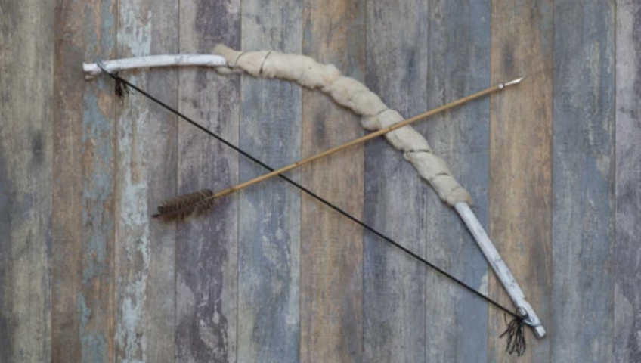
Engelska-glosor till torsdag, v 15
Chapter 21 ”Robin hood”
- robbed – rånade
- poor – fattig
- half – hälften
- lands – ägor, mark
- wife – fru
- arrow – pil
- tried – försökte
- shouted – skrek
- quietly – tyst An old bow and an arrow.
- sadly - sorgset
Learn the words. Listen to and read the chapter on your
iPad (www.studentlitteratur.se). Practice writing the words in a sentence. Good luck! / David
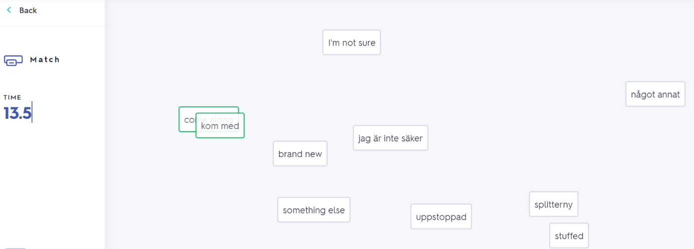
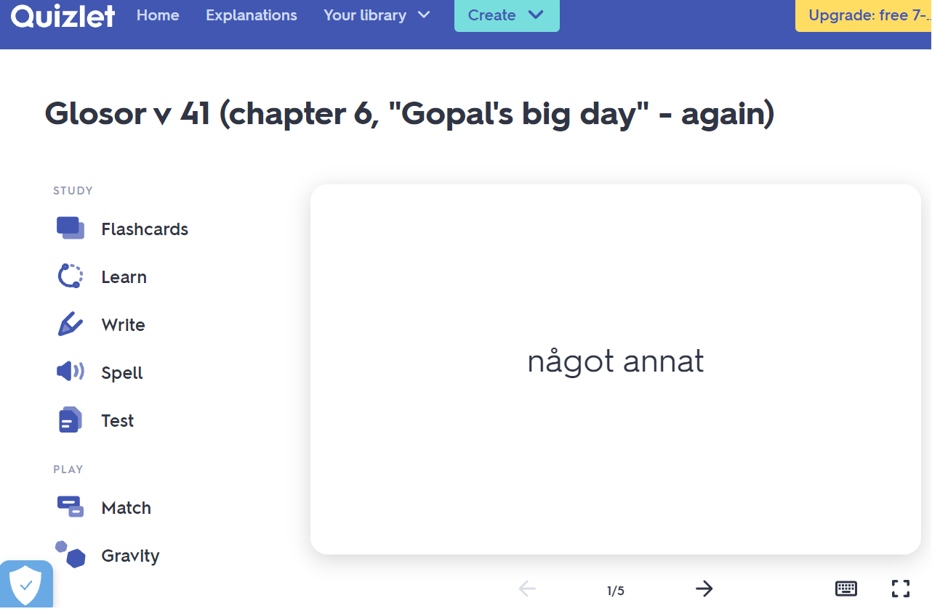
If you want to: Try practicing this week’s glosor at Quizlet if you want to!
Find the link on Teams or at Noretskolan’s website!

