Klass 5B, Noretskolan
Engelska-glosor till torsdag, v 3
Chapter 12 ”Fun in school” (a few words are from chapter 13, but you do not have to read that chapter).
- responsible for – ansvarig för
- perform – framföra
- suggest – föreslår
- actors – skådespelare
- actresses - skådespelerskor
- named – (som) heter A stage
- ill – sjuk
- cinema - bio
Learn the words. Listen to and read the chapter on your
iPad (www.studentlitteratur.se). Practice writing the words in a sentence. Good luck! / David
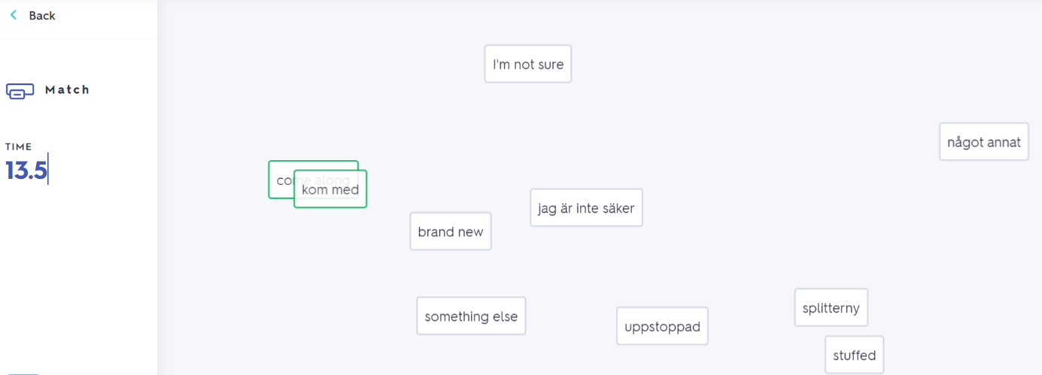
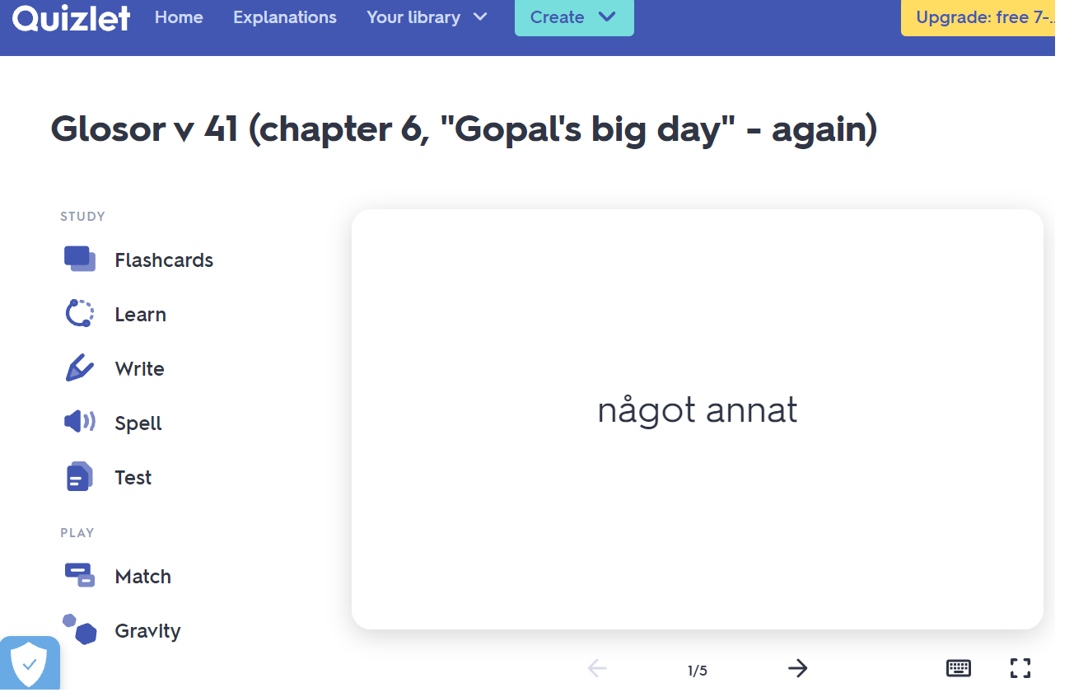
If you want to: Try practicing this week’s glosor at Quizlet if you want to!
Find the link on Teams or at Noretskolan’s website!

