Klass 5B, Noretskolan
Engelska-glosor till torsdag, v 18
Chapter 22 ”Robin hood”
- greedy – girig
- followed – följde med
- arms – armar
- smiled – log
- grandson – barnbarn
- make a fire – göra upp eld
- second home – andra hem
- forget - glömma
A bow and an arrow.
Learn the words. Listen to the chapter on your iPad (www.studentlitteratur.se) and read the script(manus). Practice writing the words in a sentence. Try to use subject pronouns(personliga pronomen) in these sentences (I, you, he, she, it, we, you, they).
Good luck! / David
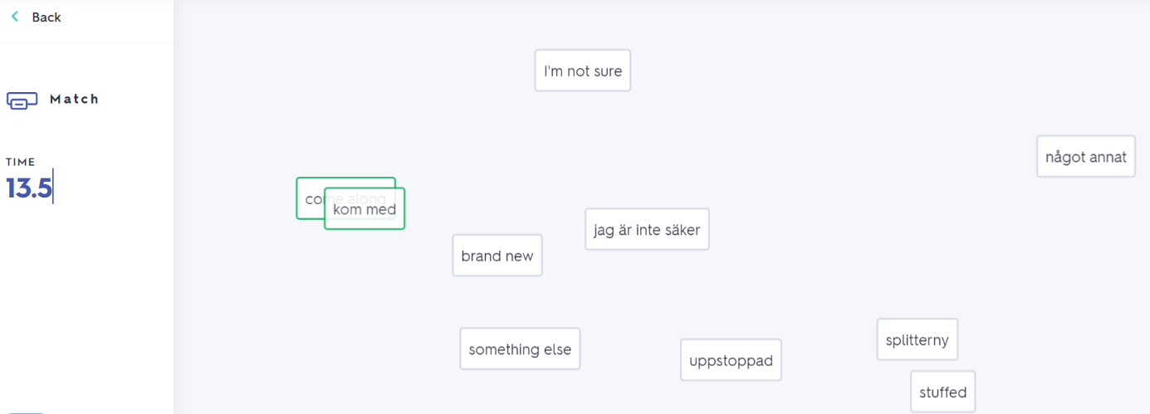
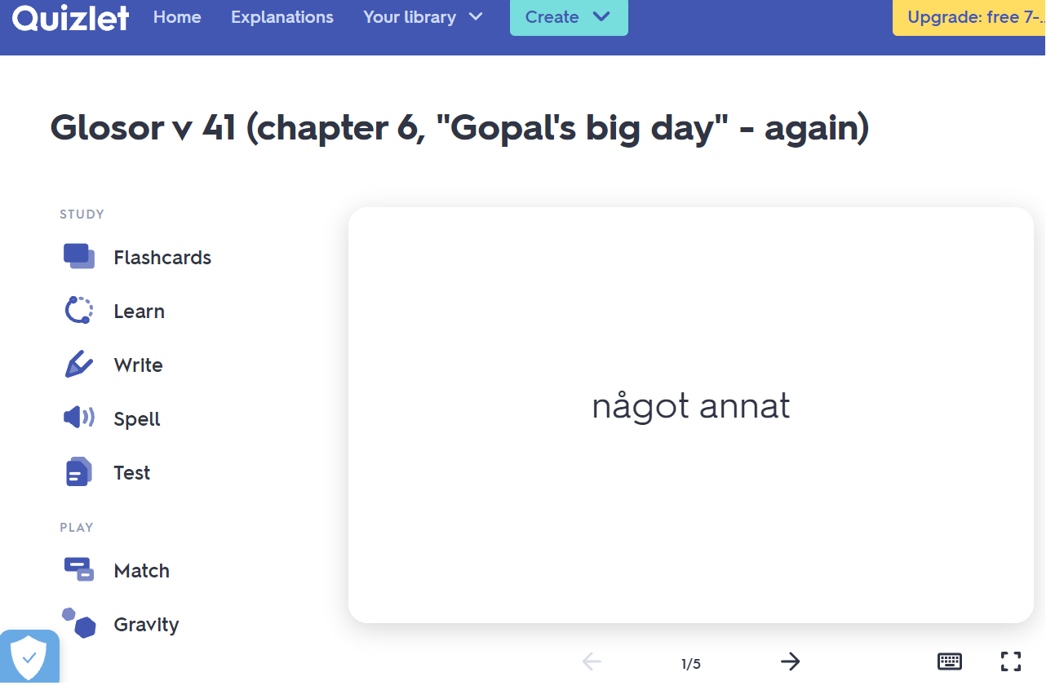
If you want to: Try practicing this week’s glosor at Quizlet if you want to!
Find the link on Teams or at Noretskolan’s website!

