Klass 5B, Noretskolan
Engelska-glosor till torsdag, v 8
Chapter 15 and 16. Notice that we have already worked with these chapters before.
- talent shows – talangjakter
- Go on! – Fortsätt!
- is chasing – jagar
- whole – hela
- catch up – komma ikapp
- sound – låter
- screen – skärm
- diseases – sjukdomar

Learn the words. You don’t have to read the chapters on your
iPad (www.studentlitteratur.se), if you have already read them before. Practice writing the words in a sentence. Good luck! / David
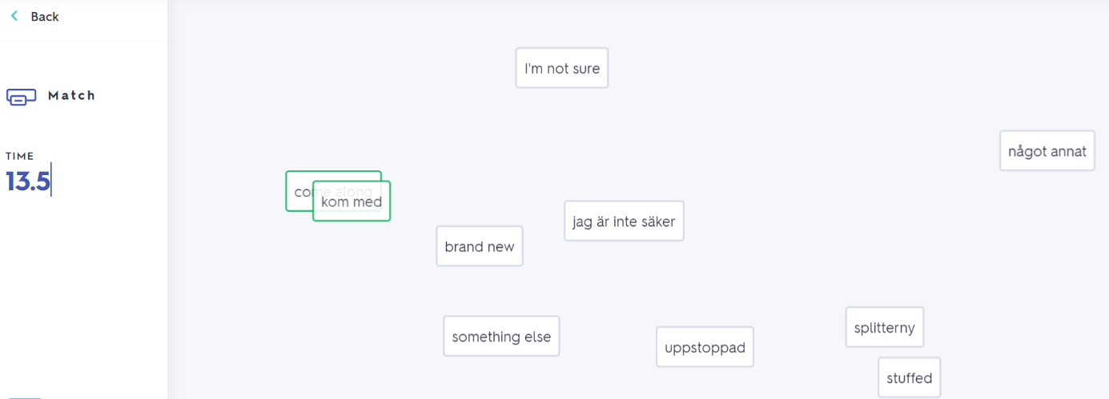
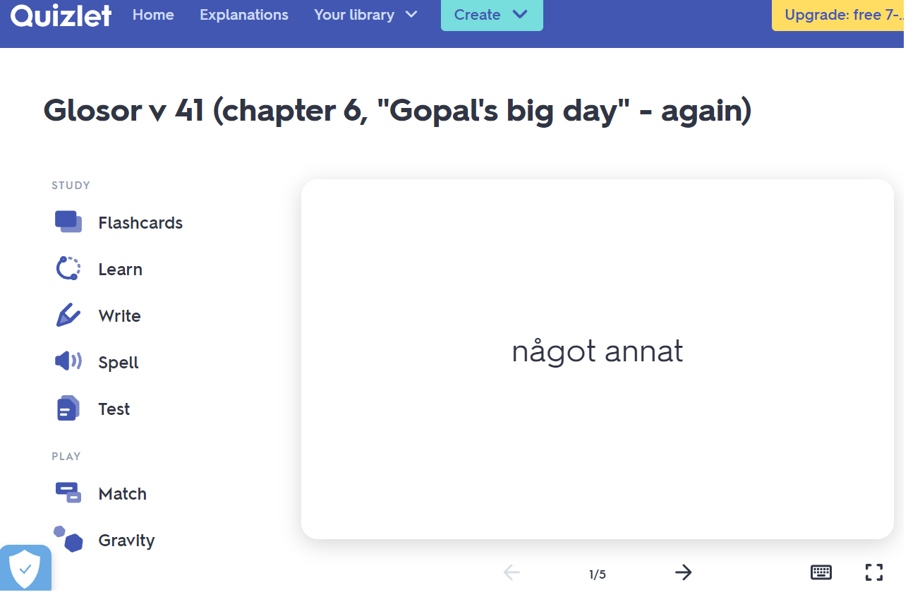
If you want to: Try practicing this week’s glosor at Quizlet if you want to!
Find the link on Teams or at Noretskolan’s website!

