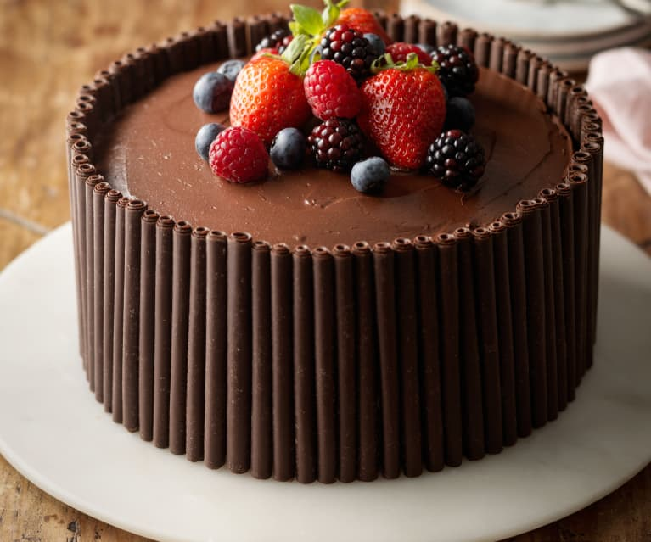
Klass 5B, Noretskolan
Engelska-glosor till torsdag, v 6
Chapter 19 ”Yummy! Sticky chocolate cake”
- yummy – smaskigt
- fridge – kylskåp
- let’s see – låt oss kolla
- butter – smör
- vegetables – grönsaker
- sort of – ganska a chocolate cake
- sugar – socker
- oven – ugn
- enough – tillräckligt
- careful – försiktig
Learn the words. Listen to and read the chapter on your
iPad (www.studentlitteratur.se). Practice writing the words in a sentence. Good luck! / David
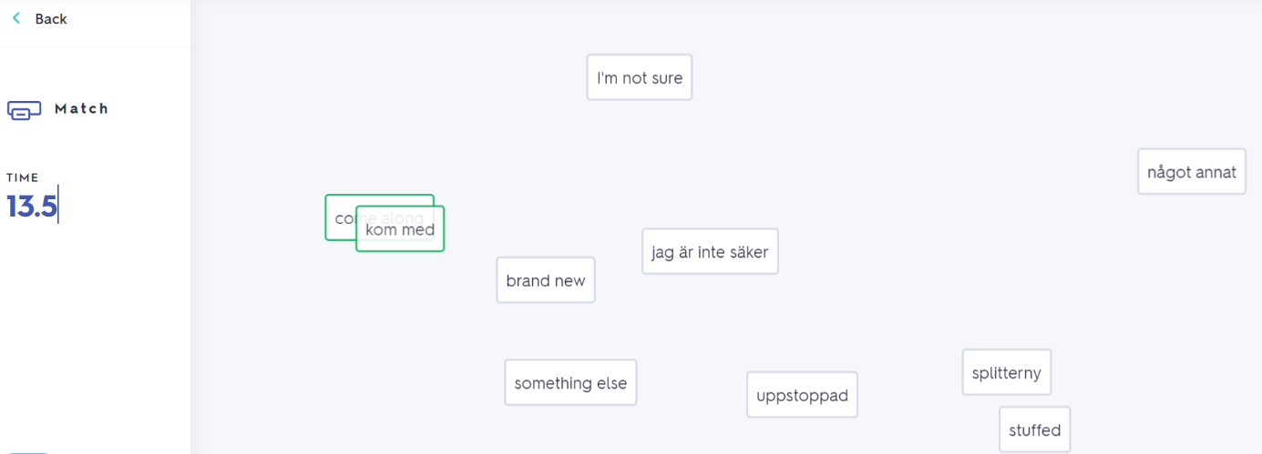
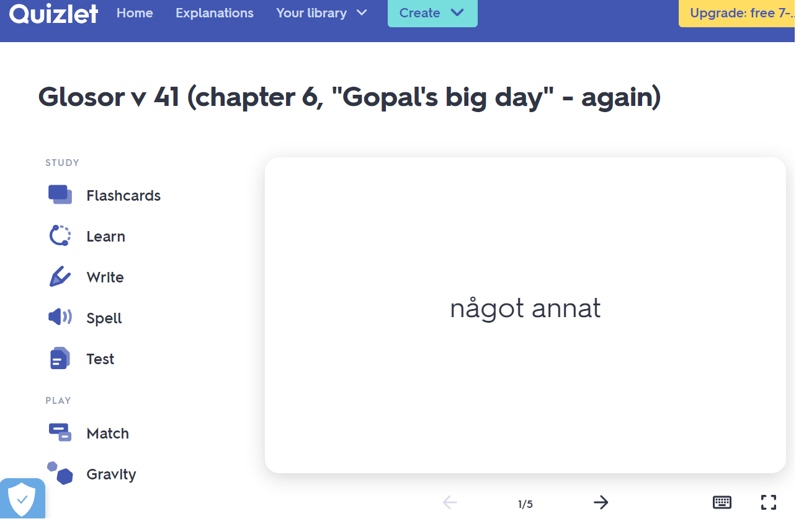
If you want to: Try practicing this week’s glosor at Quizlet if you want to!
Find the link on Teams or at Noretskolan’s website!

