Klass 5B, Noretskolan
Engelska-glosor till torsdag, v 5
Chapter 15 ”The musical”
- inspired by – inspirerad av
- fall in love – bli kära
- break up – göra slut
- exciting – spännande
- a happy ending – ett lyckligt slut a microphone
- talented – begåvade
- area – område
- mean – elak
Learn the words. Listen to and read the chapter on your
iPad (www.studentlitteratur.se). Practice writing the words in a sentence. Good luck! / David
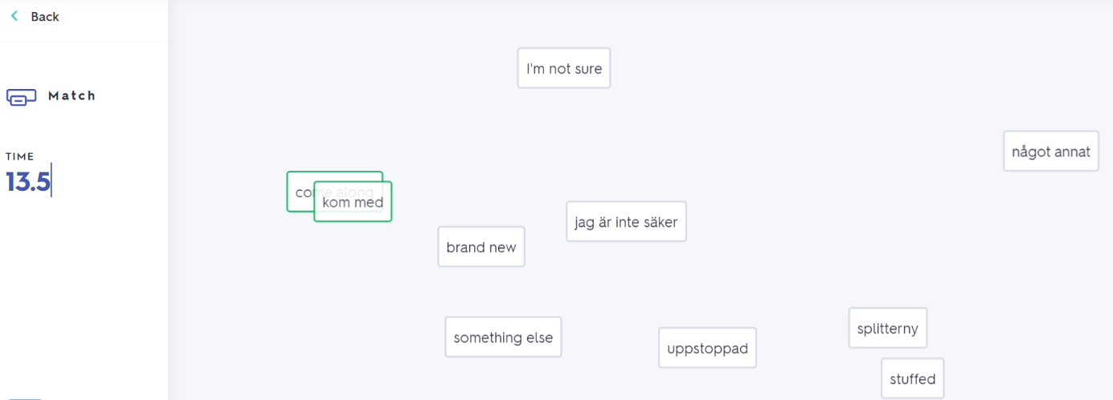
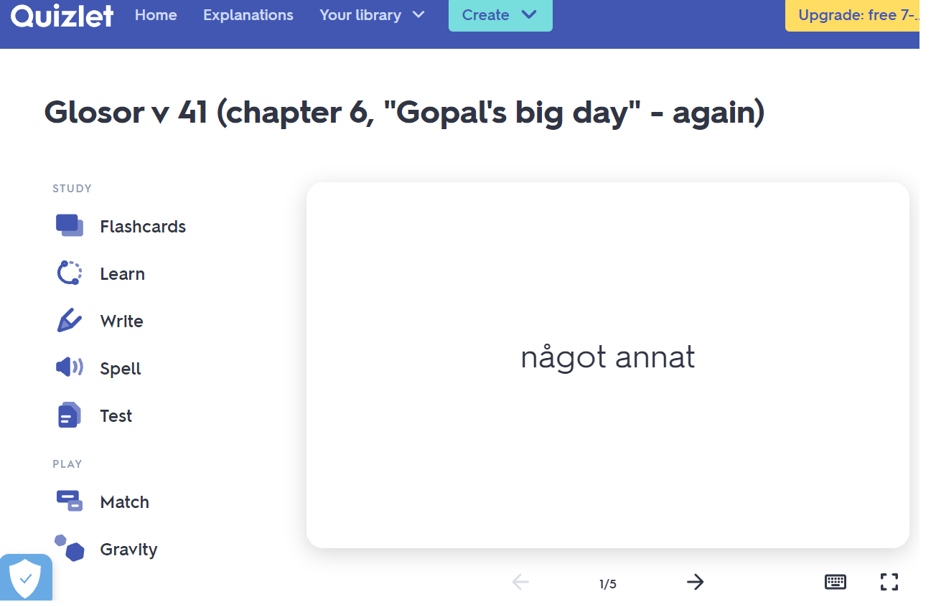
If you want to: Try practicing this week’s glosor at Quizlet if you want to!
Find the link on Teams or at Noretskolan’s website!

