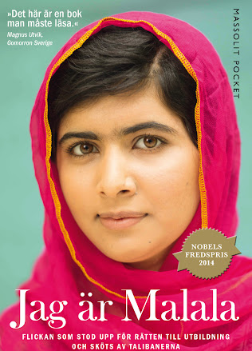
Klass 5B, Noretskolan
Engelska-glosor till torsdag, v 46
(chapter 9 ”Malala”)
- speech - tal
- forehead - panna
- weakness - svaghet
- courage - mod
- strength - styrka
- bullet - kula
- failed - misslyckades
- wrote (write) - skrev

Learn the words. Listen to and read the chapter on your
iPad (www.studentlitteratur.se). Practice writing the words in a sentence. Good luck! / David
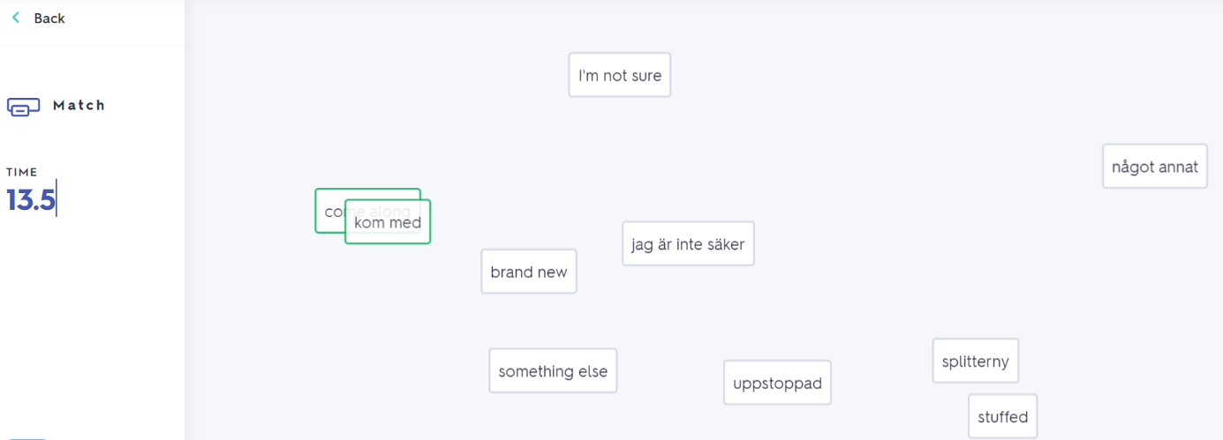
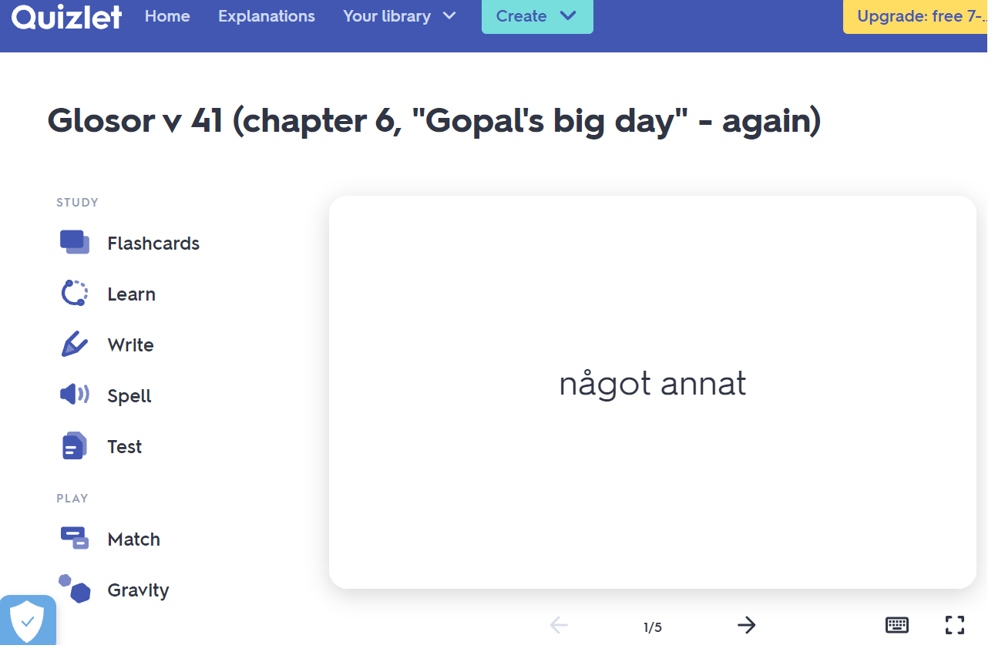
News! Try practicing this week’s glosor at Quizlet if you want to!
Find the link on Teams or at Noretskolan’s website!

