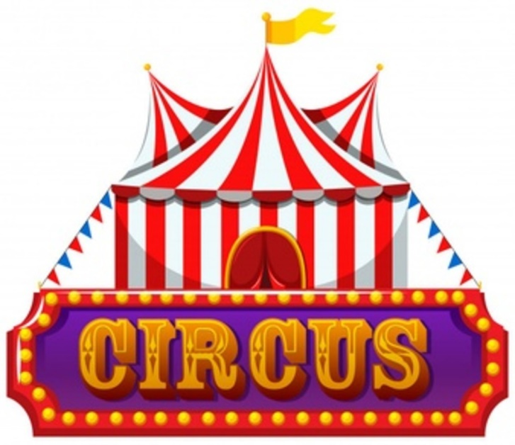
Klass 5B, Noretskolan
Engelska-glosor till torsdag, v 42
(chapter 7 ”At the circus”)
- mouth – mun
- ears – öron
- shoulders – axlar
- back – rygg
- hands - händer
- is limping – haltar
- swimsuit – baddräkt
- is wearing – har på sig
- ground – mark
- carries (carry) - bär

Learn the words. Listen to and read the chapter on your
iPad (www.studentlitteratur.se). Practice writing the words in a sentence. Good luck! / David
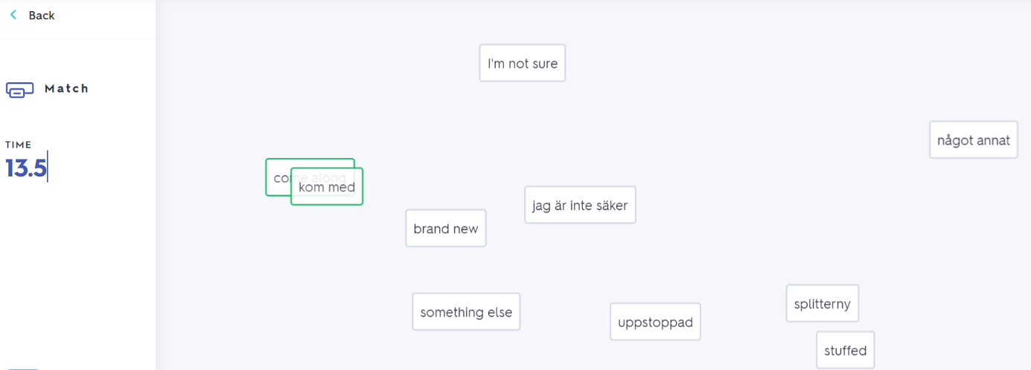
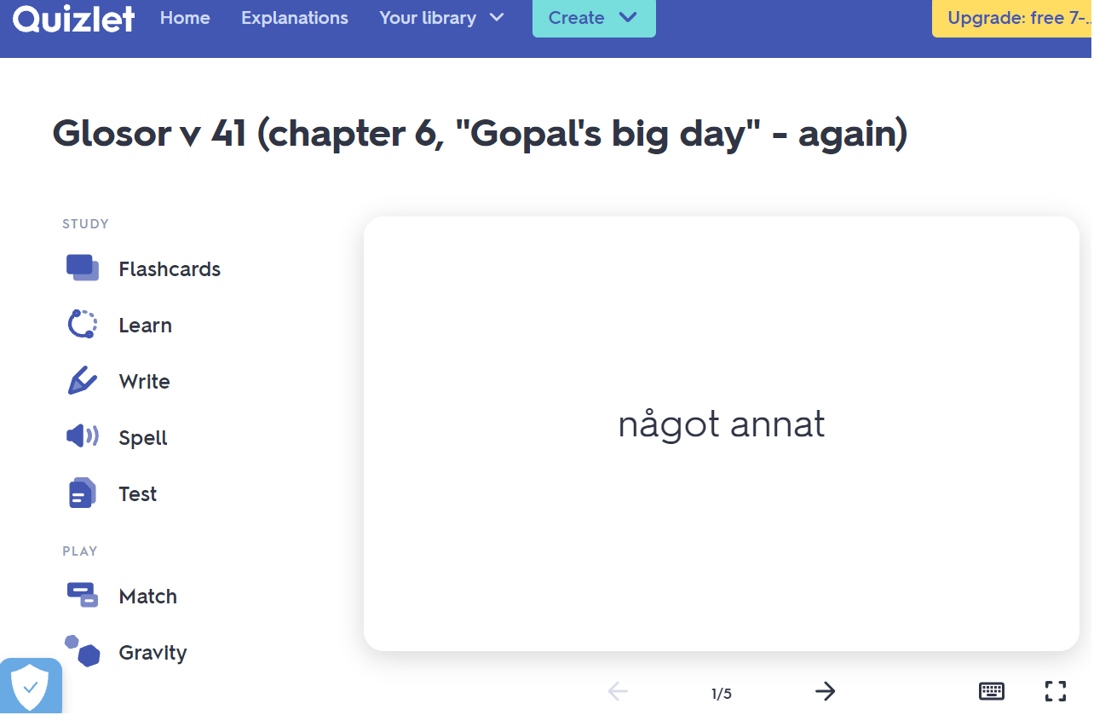
News! Try practicing this week’s glosor at Quizlet if you want to!
Find the link on Teams or at Noretskolans website!

