Klass 5B, Noretskolan
Engelska-glosor till torsdag, v 6
Chapter 16 ”School project”
- project – projekt
- knocks - knackar
- enters – går in
- carries on (carry) – fortsätter
- website – internetsida
- without – utan
- plants – växter a fisherman
- everywhere – överallt
- rivers – floder
- dirty - smutsig
Learn the words. Listen to and read the chapter on your
iPad (www.studentlitteratur.se). Practice writing the words in a sentence. Good luck! / David
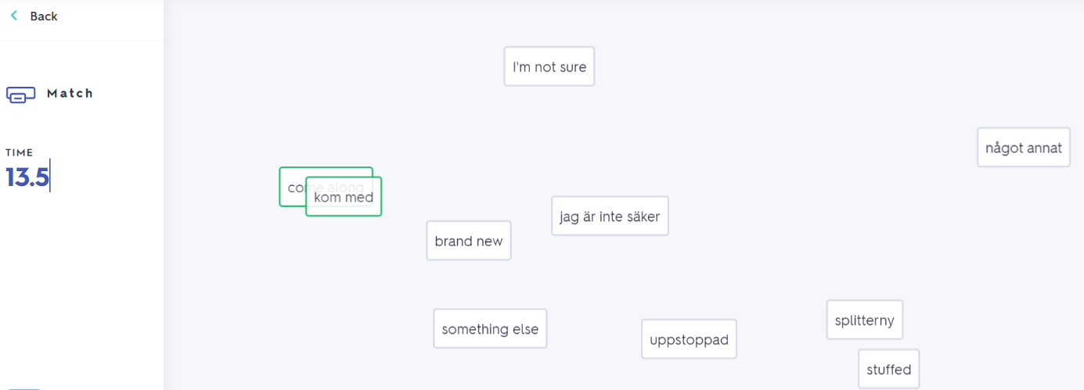
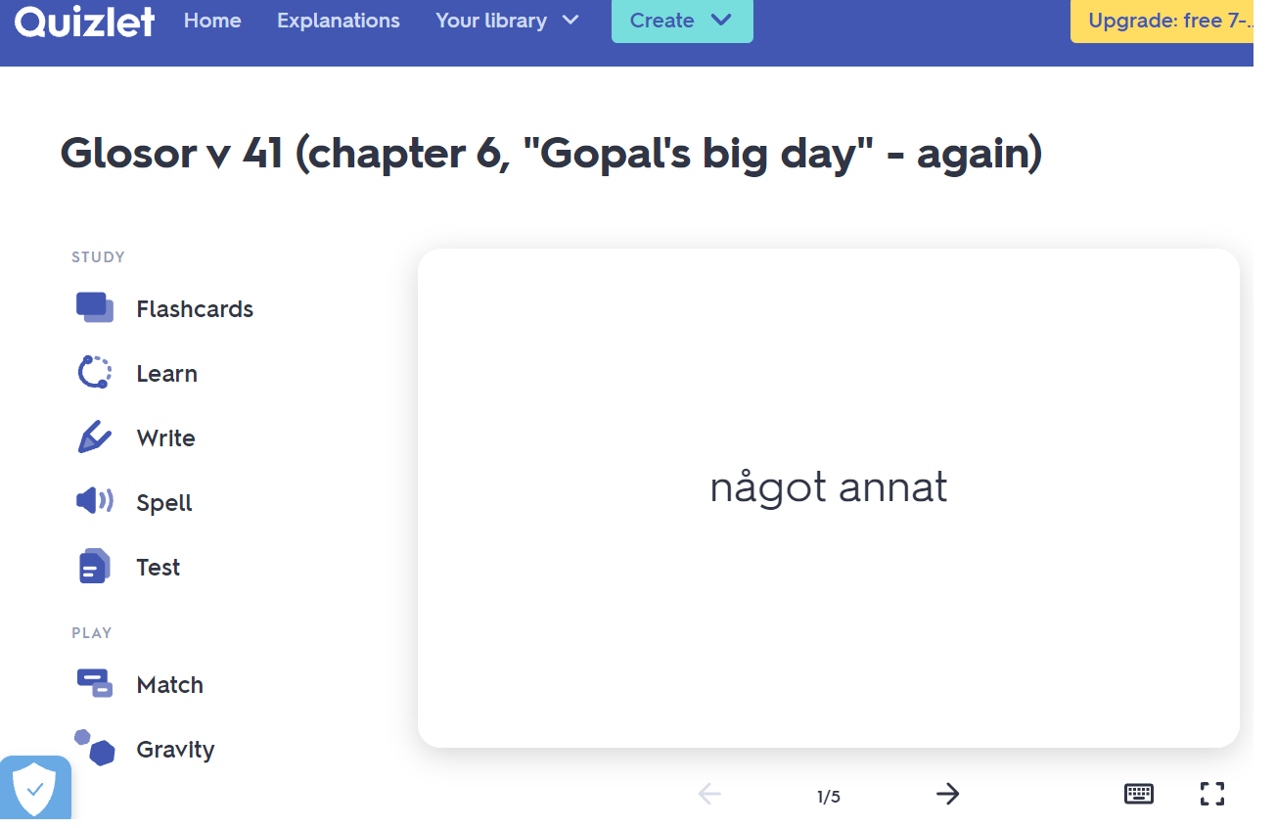
If you want to: Try practicing this week’s glosor at Quizlet if you want to!
Find the link on Teams or at Noretskolan’s website!

