Klass 5B, Noretskolan
Engelska-glosor till torsdag, v 43
(chapter 8 ”Blackmail”)
- blackmail - utpressning
- thanks to me - tack vare mig
- was elected - valdes till
- look tired - ser trött ut
- maybe - kanske
- reader - läsare
- teenagers - tonåringar
- subscription - prenumeration
- delivered - levererad
- letter - brev

Learn the words. Listen to and read the chapter on your
iPad (www.studentlitteratur.se). Practice writing the words in a sentence. Good luck! / David
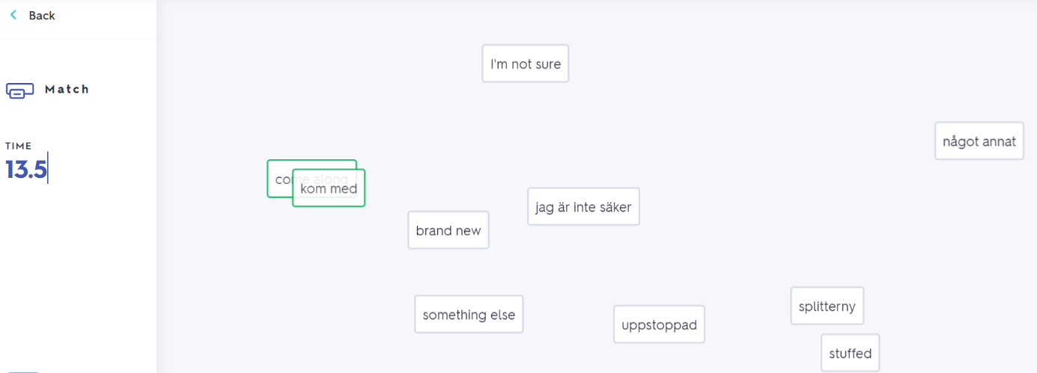
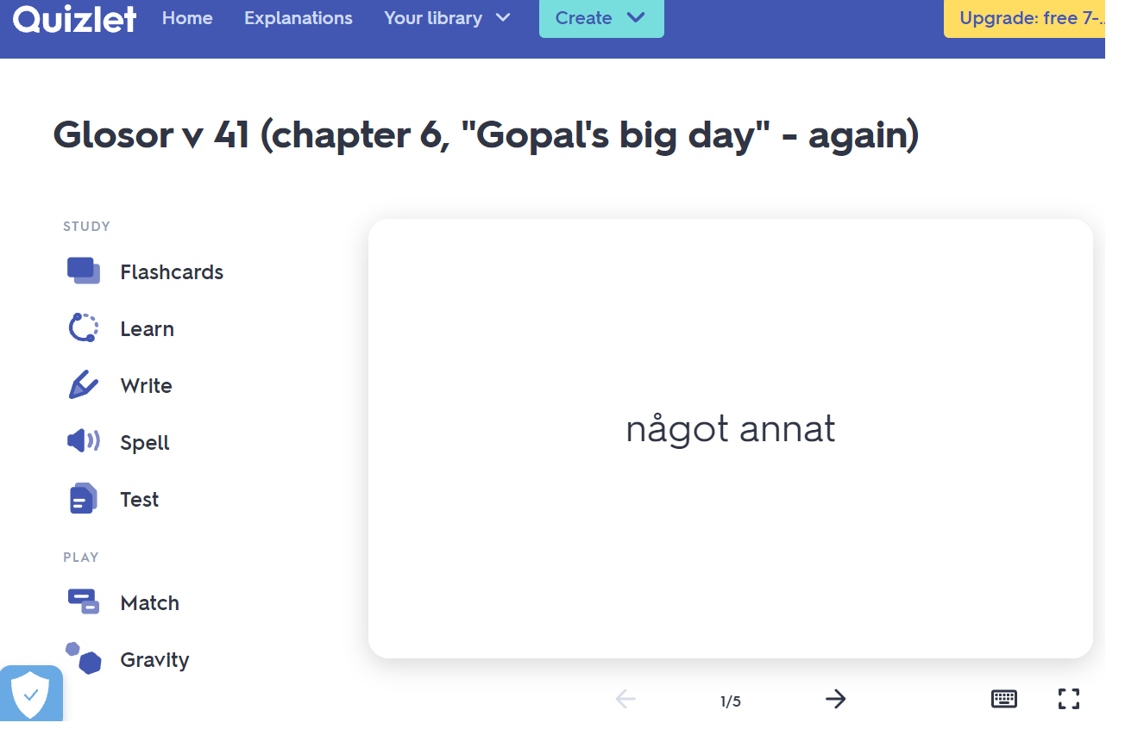
News! Try practicing this week’s glosor at Quizlet if you want to!
Find the link on Teams or at Noretskolan’s website!

