Klass 5B, Noretskolan
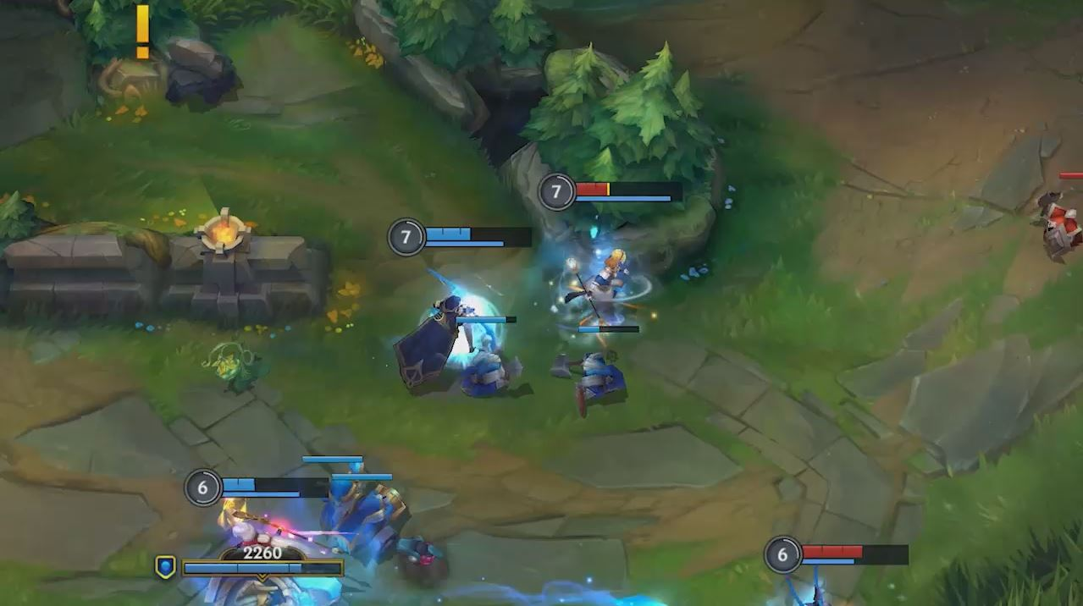
Engelska-glosor till torsdag, v 14
Chapter 20 ”Shadowslicer”
as I was saying – som jag sa
parts – delar
character – karaktär, person
warrior – krigare
forest – skog
battles – slag
realistic – trovärdig
ride on – rida på
history – historia
seriously – allvarligt talat
Learn the words. Listen to and read the chapter on your
iPad (www.studentlitteratur.se). Practice writing the words in a sentence. Good luck! / David
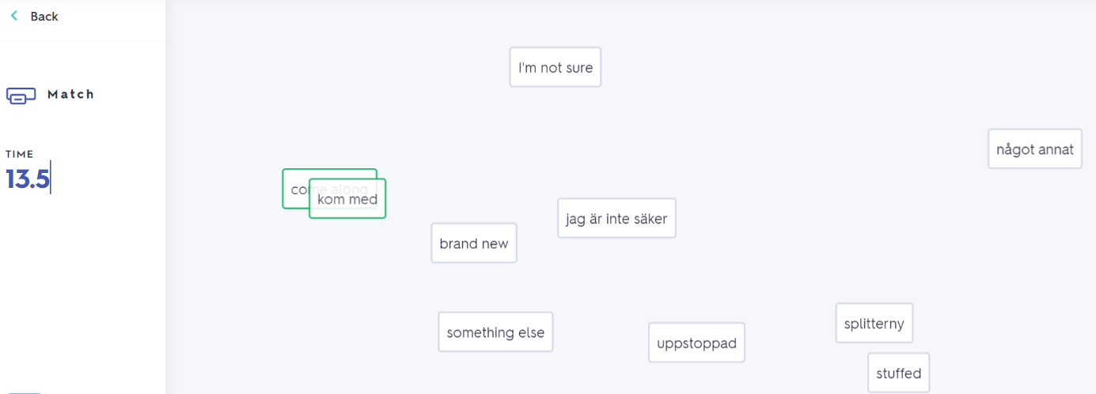
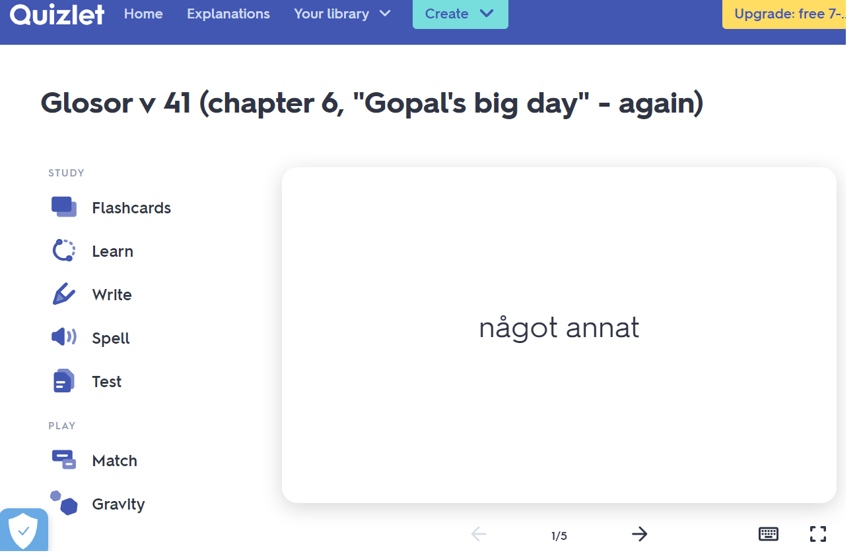
If you want to: Try practicing this week’s glosor at Quizlet if you want to!
Find the link on Teams or at Noretskolan’s website!

