Klass 5B, Noretskolan
Engelska-glosor till torsdag, v 19
Chapter 23 ”Sightseeing in New York”
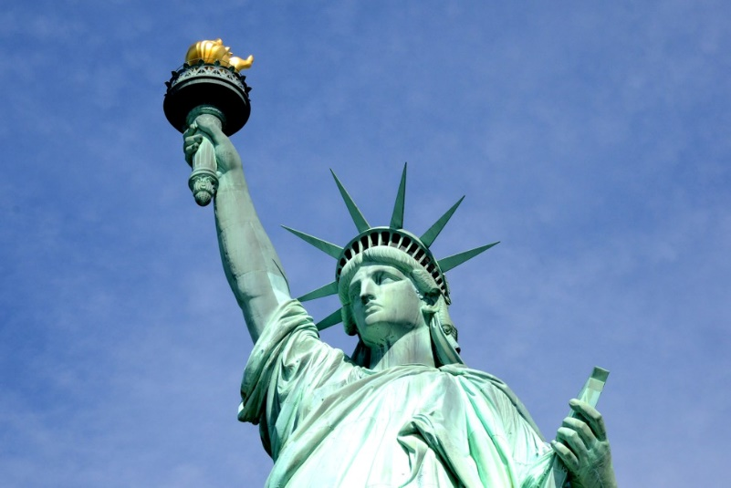
- sightseeing – rundtur
- arrive in – komma till
- twin – tvilling
- bridge – bro
- oldest – äldsta
- building – byggnad
- tallest – högsta
- was completed – gjordes färdig
- countries – länder
- mission - uppdrag The Statue of Liberty in New York
Learn the words. Listen to and read the chapter on your
iPad (www.studentlitteratur.se). Practice writing the words in a sentence. Good luck! / David
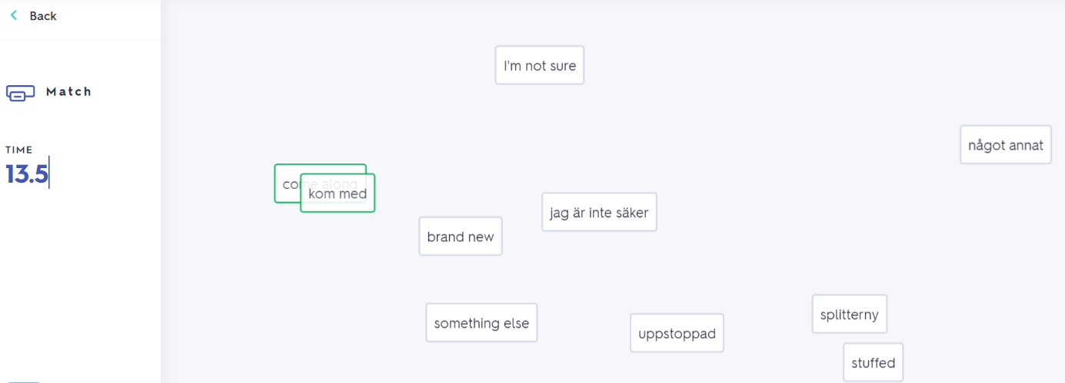
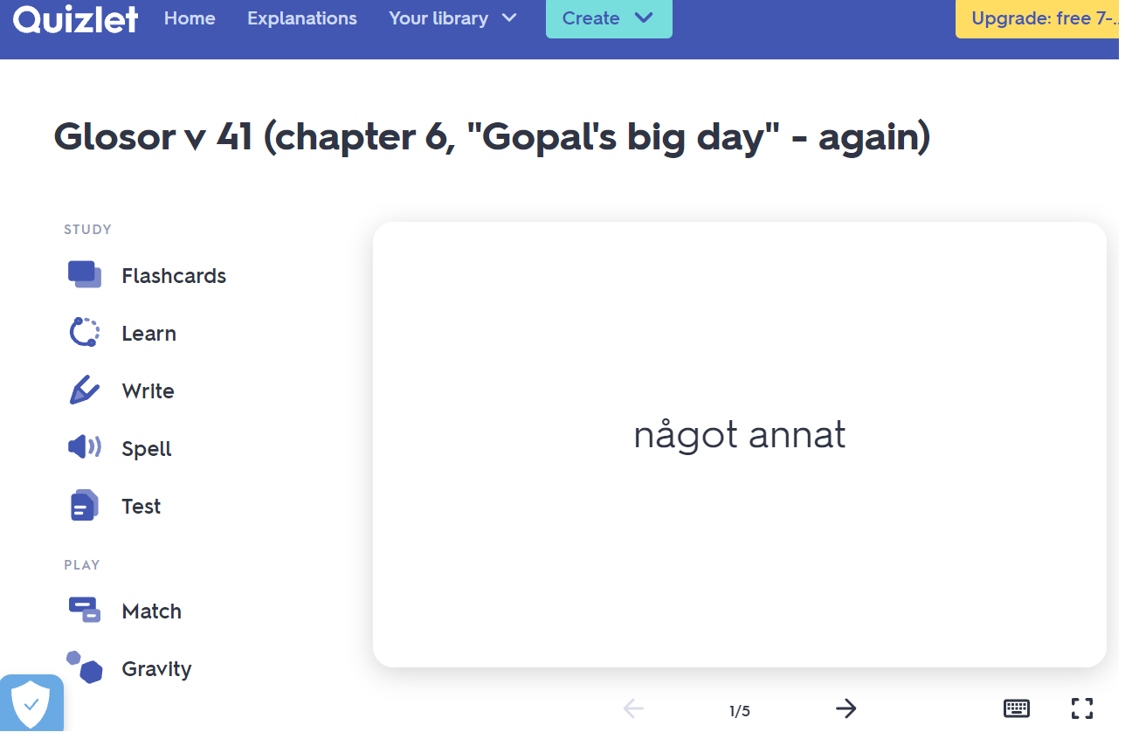
If you want to: Try practicing this week’s glosor at Quizlet if you want to!
Find the link on Teams or at Noretskolan’s website!

